**NIGERIAN ECONOMICS STUDENTS ASSOCIATION, NNAMDI AZKIKIWE UNIVERISITY (NESANAU) WEBSITE PROJECT COPY**

**Homepage**

We are proud members of the Nigerian Economics Students Association

**About Nesanau**

**Nesanau** is Nnamdi Azikiwe University's extension of the [NESA national body](https://www.nesanational.com/) (a student body of the [Nigerian Economics Society](https://www.google.com/url?sa=t&source=web&rct=j&url=https://www.nigerianeconomicsociety.org/&ved=2ahUKEwj06fv94obtAhVjQkEAHX42AqcQFjAAegQIARAB&usg=AOvVaw0GajFu3MxjRxMp57eURyNo)) which is an umbrella for all economics students in Nigeria with over 120,000 members drawn from 83 universities across the country. We are a group of students and youths who believe in the Nigeria project, thus challenging ourselves to promote national integration, enterprise, and utilize every opportunity we have to make meaningful contributions that will enhance the peace and progress of our dear country and the world at large.

**Our Vision**

To be a body of globally recognized economics student association saddled academically, socially and mentally to support institutional dynamism and economic development.

**Our Mission**

To provide a cutting edge platform for equipping members with needed skills and information to tackle contemporary challenges.

**Our Responsibility**

* **Exposure**: To expose members to institutional work experience as interns( (Virtual or Traditionally), host enlightenment meetups (Webinars or Traditional meetups ) and scholarships schemes.
* **Impact**: to create a veritable platform that allows for societal impact through participation in strategic event, conferences and workshops.
* **Self-help**: to see to the socio-economic welfare of members as is meet.
* **Society**: to give back to the society as volunteers in sustainable development goals.

**Our team:** photos and short bios will be made available.

**President Nesanau – Victor Ojimadu**



Victor Ojimadu is a young, valiant and visionary leader who is inspired by necessity to be innovative. He is often commended for his unorthodoxy in solving problems and recognized by peers as hardworking. He is humble, confident, outspoken with strong relational skill. His interest is business, Fintech, project management and system improvement solutions. At leisure he loves to connect with friends and play music.

[LinkedIn](https://www.linkedin.com/in/victor-ojimadu-viraculous-277358158) **|** [Twitter](https://twitter.com/VViraculous?s=09)

**Vice President Nesanau– Ike Patricia Chisom**

**Coming soon…..**

**Financial Secretary Nesanau-- Enibe Blessing**

Enibe Chidiebere Blessing is a 300 level student of Economics, Nnamdi Azikiwe University. She believes there's no stop to learning as we learn, unlearn and relearn to become better people. She is passionate about giving back to the community and being a better person.

[LinkedIn](https://www.linkedin.com/in/enibe-blessing-282a281a5)

**Nesanau Treasurer**– **Nwosu Kelechi**

**Assistant financial secretary Nesanau– Nwonye Ozioma**

Ozioma Nwonye is currently in her second year of studying economics at Nnamdi Azikiwe University.She is a positive and ambitious person who has developed a responsible approach to overcoming tasks placed before her.She has a genuine interest in business and loves baking.

[LinkedIn](https://www.linkedin.com/in/ozioma-nwonye-7694321b9)

**Secretary General Nesanau– Bridget Nwanwo**

Chioma Bridget Nwankwo is a young vibrant lady, systematic, a new breed without greed. Her motto is; don't let what you can't do, take from you what you can do. She's interested in youth empowerment, leadership initiatives and being in a close relationship with God.

[LinkedIn](https://www.linkedin.com/in/chioma-nwankwo-2405641a9)

Assistant Secretary general Nesanau– Munachiso

Director of Sports Nesanau– Chima Uzoigwe

**Director of Socials Nesanau– Cedric Elong**

Elong Cedric Emeka Is a 300 Level student of Economics, a Politician, Passionate leader, Social Affairs Director and enthusiast. He has interests in people's social lives, activities and welfare. He is also a talented drummer and a Multilinguist.

He is Jovial, fun to be with and free with everyone and loves chatting during leisure time.

Public Relations Officers Nesanau– Charlse Blaise

**Assistant public relation officer Nesanau—Ubammadu Chukwudeberem**

****Chukwudeberem Ubammadu, a 200 level economics student, has an interest in healthy politics/ leadership for the common good of humanity, lover of God and a business tycoon to the economy’s credit. He Loves travelling, believes in achieving greatness and he is lovely to understand.

[LinkedIn](https://www.linkedin.com/in/chukwudeberem-ubammadu-555a2a1b6)

**Provost: Eke Chukwu**

****Eke Chukwu is a young major in Economics with passion for excellence and relentlessness. He aspires to be an job creator cum entrepreneur. In his leisure moments he loved to engage himself with impactful games like football.

[Facebook](https://www.facebook.com/eke.chukwu.9231)

Senate president Nesanau– Amaechina Kingsley

PAREF President: Nworah Adaobi

PAREFS Vice-president: Onuoha Nkemjika

PAREF Director of Media: Nwafor Chidera

PAREF Director of research and program(DRAP): Agunwa Callistus

PAREF Assistant DRAP: Bridget Nwankwo

PAREF Content Editor: Coming soon

NAFECS President: Coming soon

NAFECS Vice president: Coming soon

NAFECS Treasurer: Coming soon

Igwe Nesanau

Lolo Nesanau

Staff Adviser Nesanau – Dr. Olise Dennis Maduka

Head of Department(Economics) – Prof. Ebele Nwokoye

Our students and lecturer gallery

**Regular**

**Class of 2019**

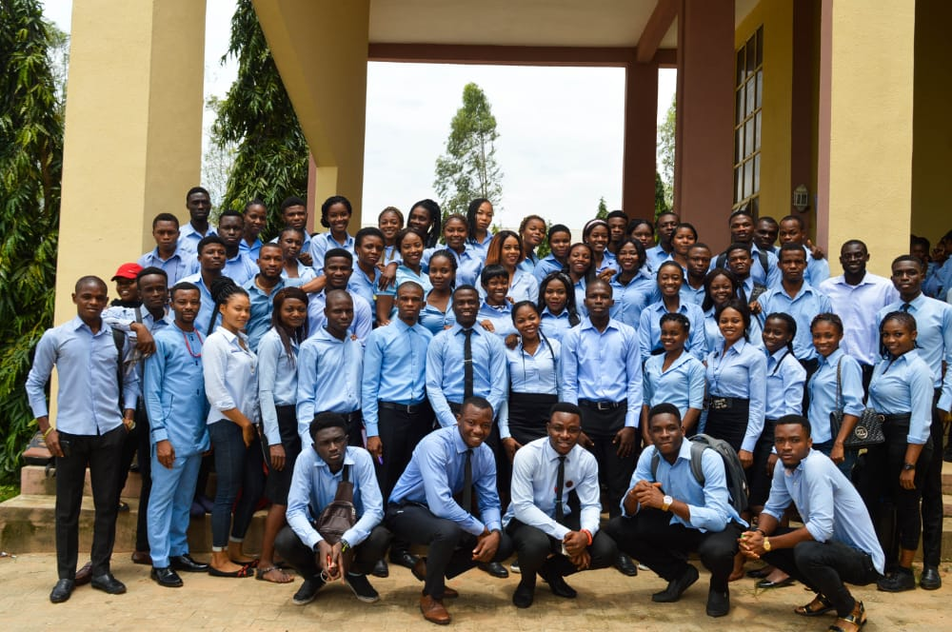

Class of 2020

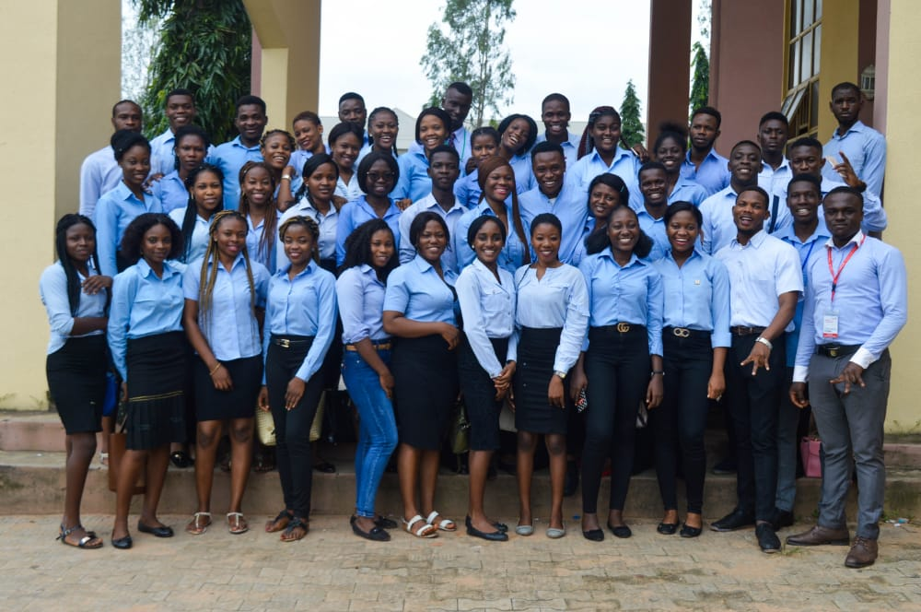

Class of 2021

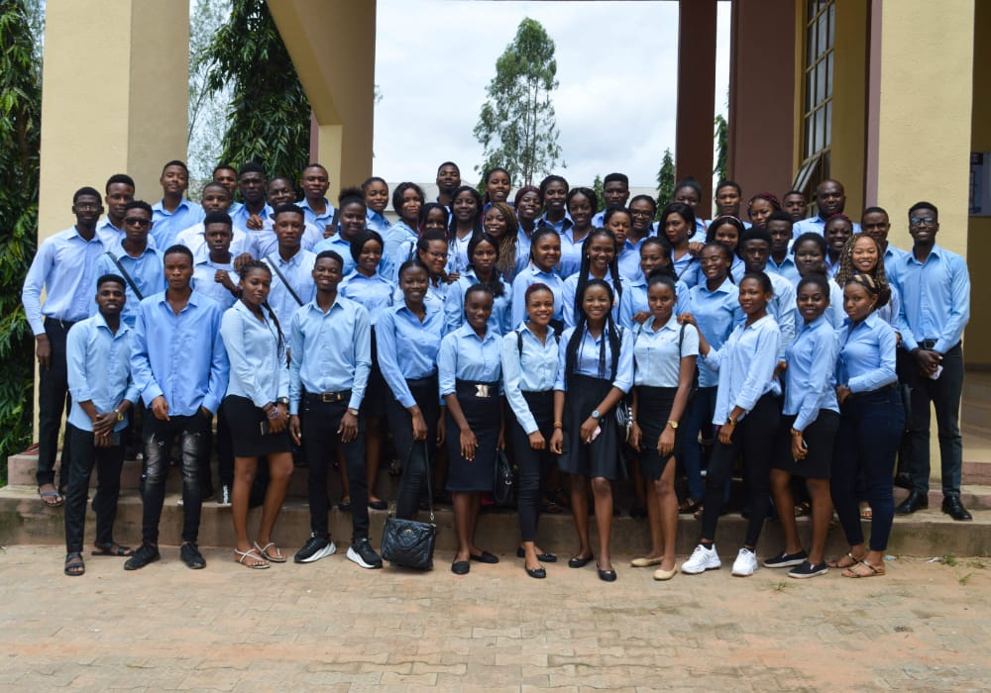

Class of 2022

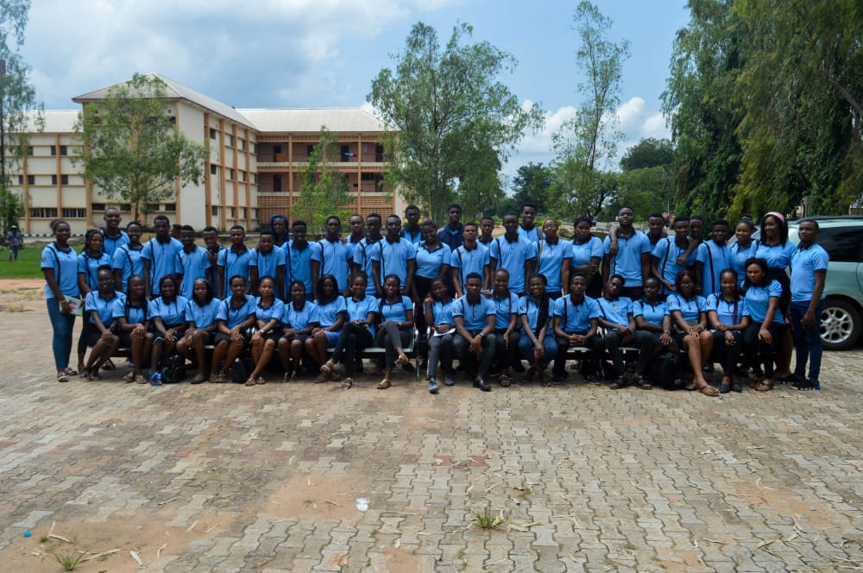

**Continuous Education Program(CEP)**

Year 3

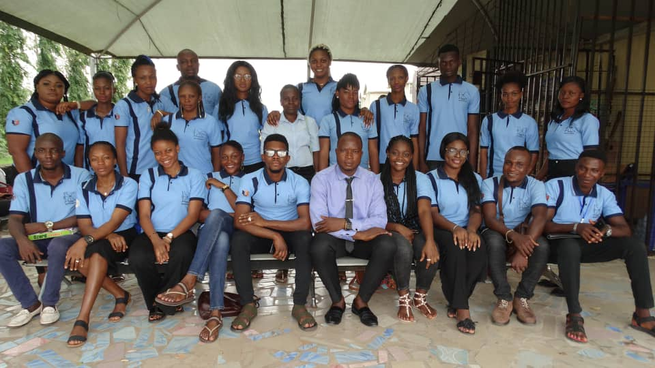

Year 2

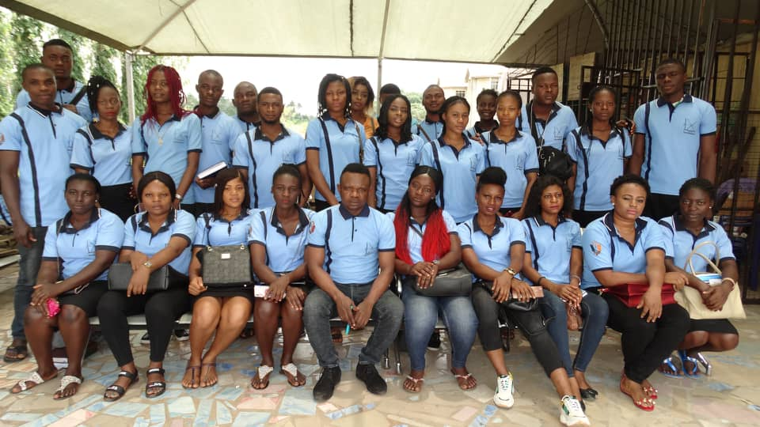Class representative of 2019

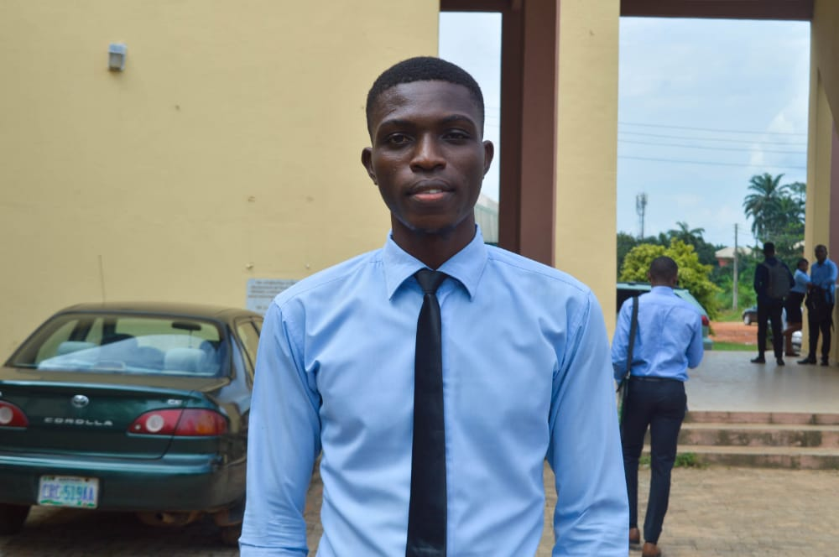

Class representative of 2020



Class representative of 2021

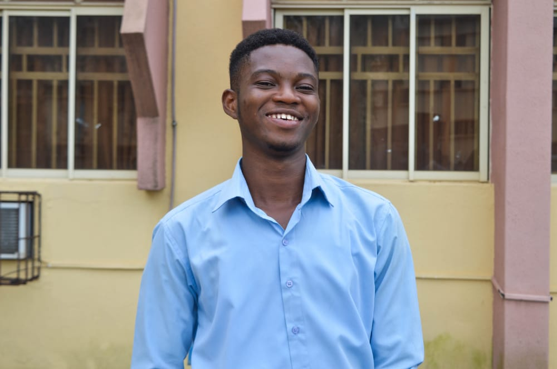

Class representative of 2022

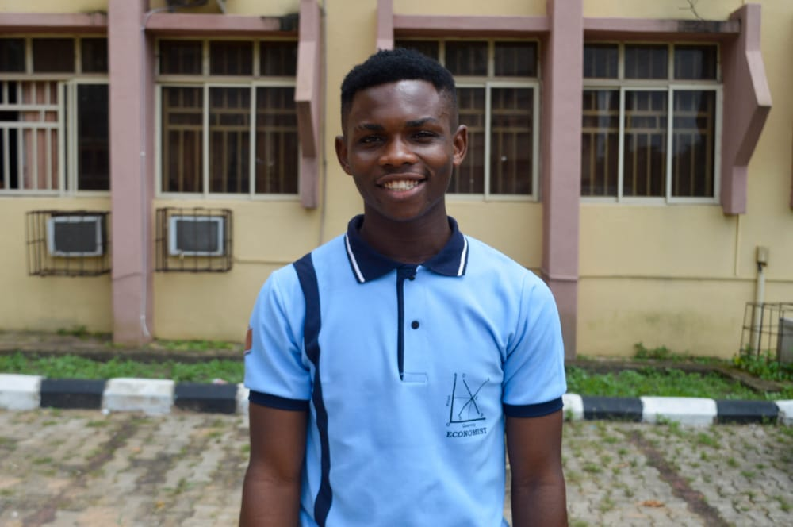

Former Nesanau president

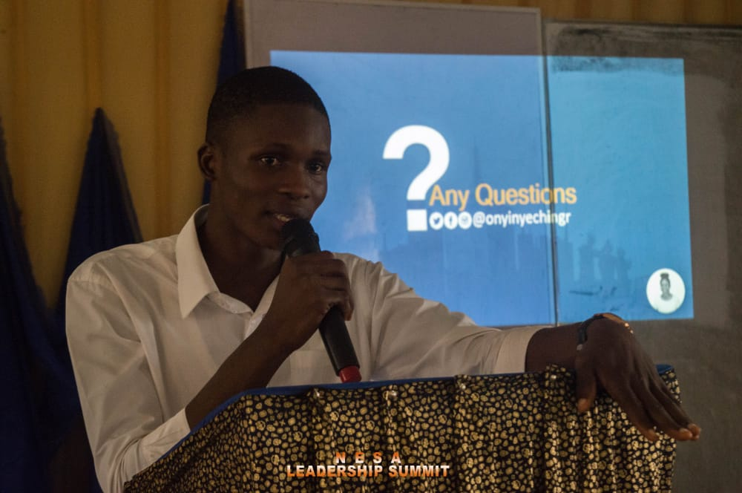

Former PAREF president

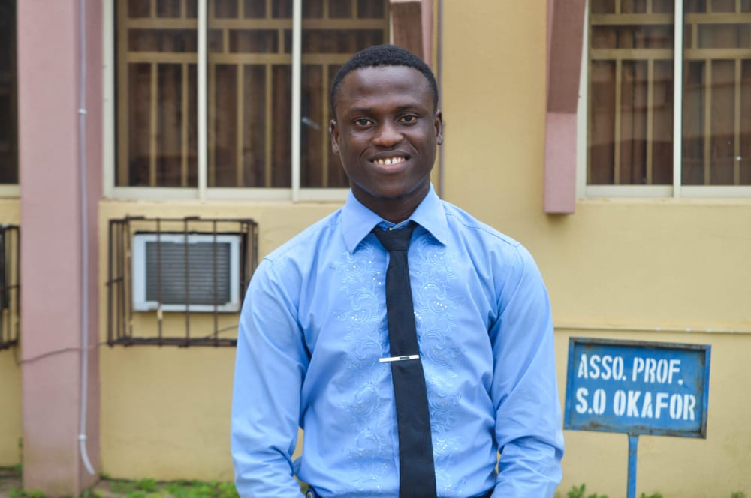

Former Nesanau Senate president

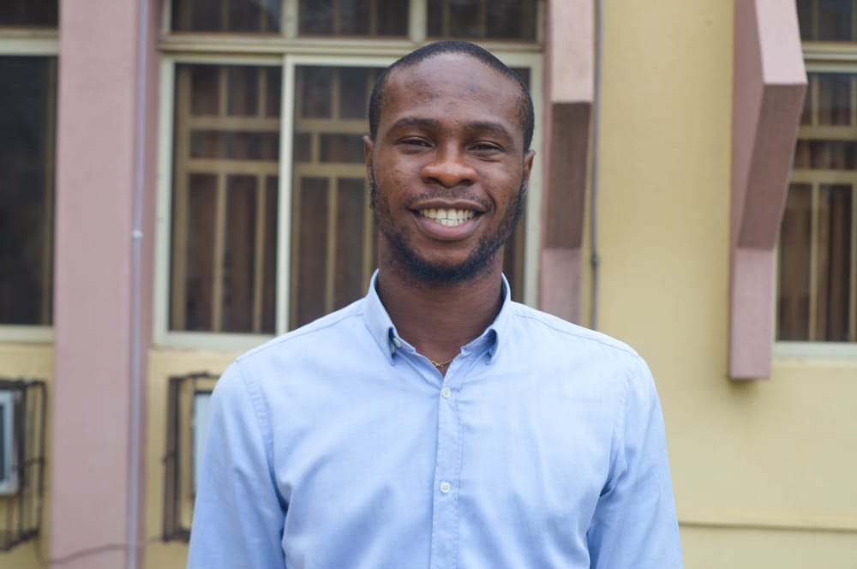

Former Nafecs president: not yet available

Class of 2018

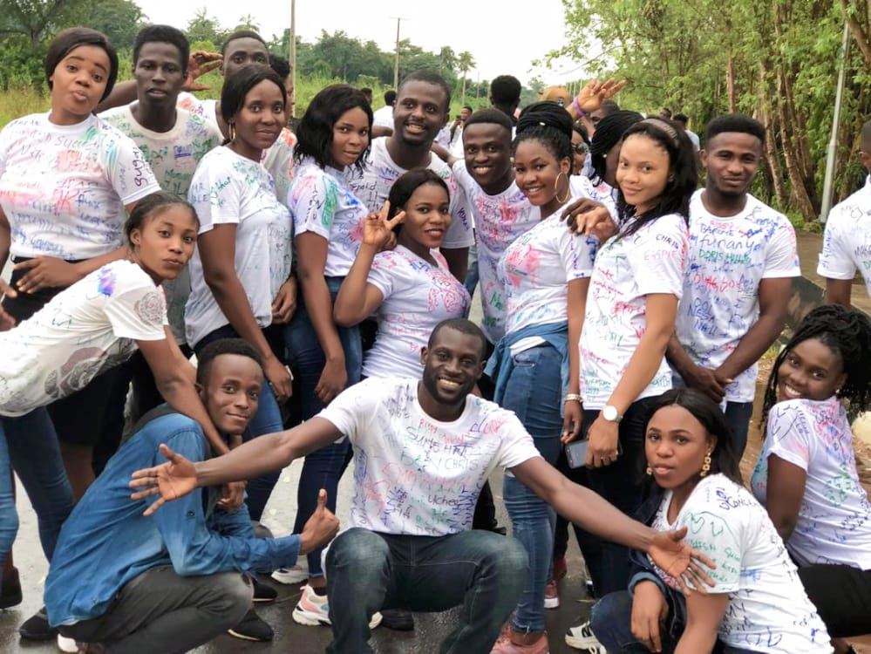

Nesanau Leadership summit

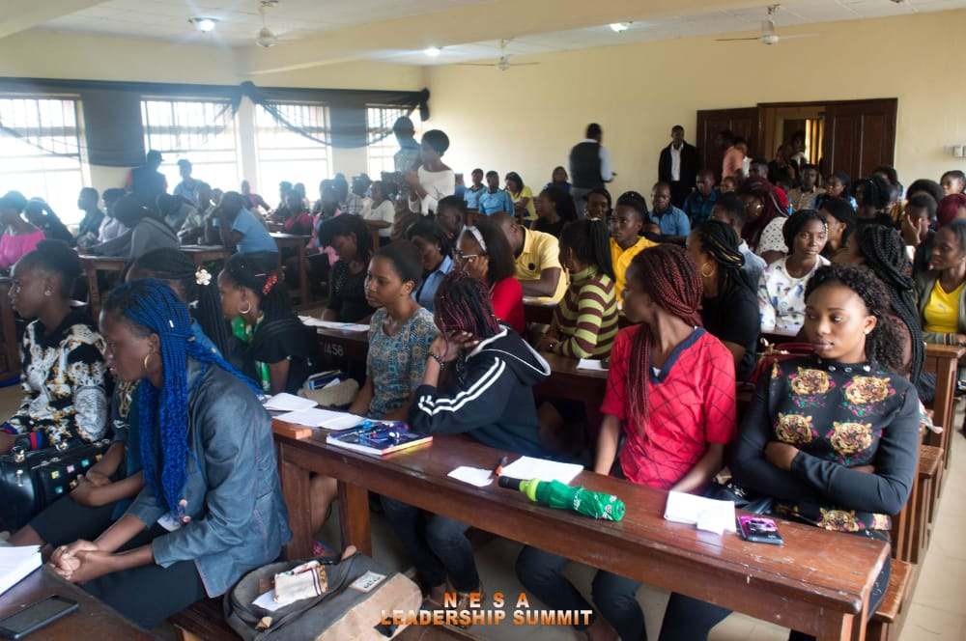

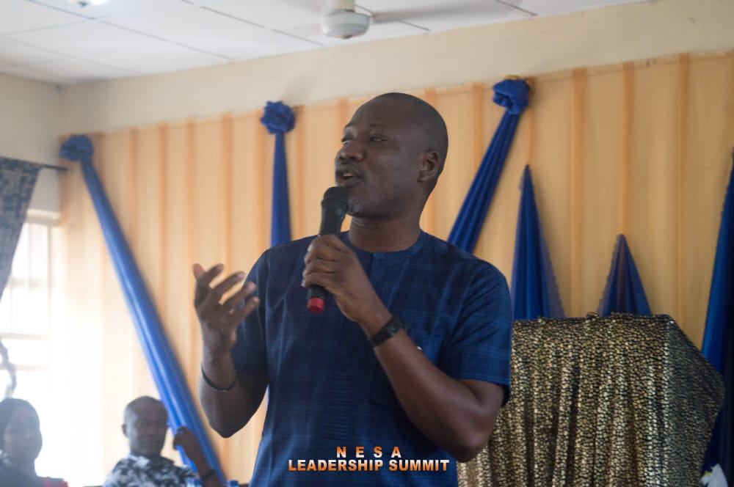Hon. Smart Okeke at Nesanau

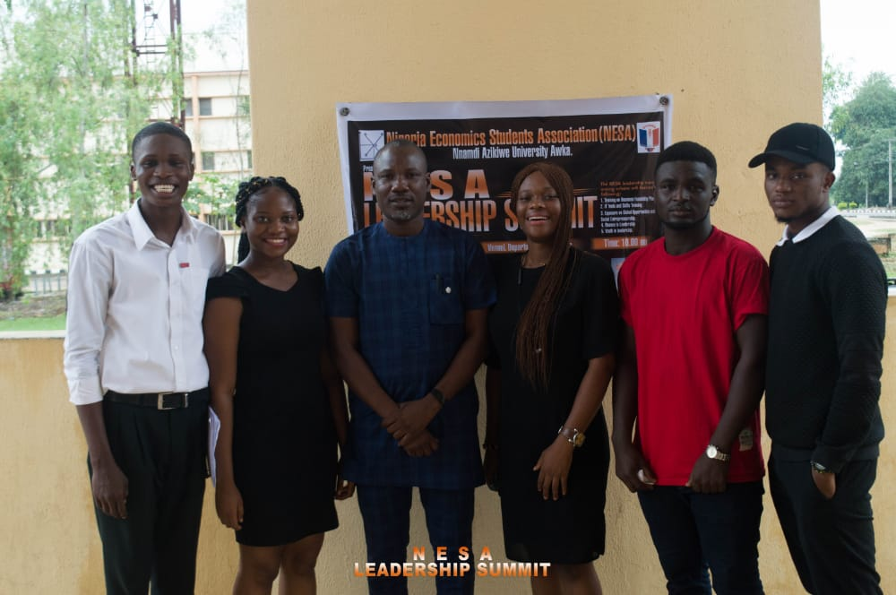Hon.Smart and Nesaites

Nesanau cultural couture display

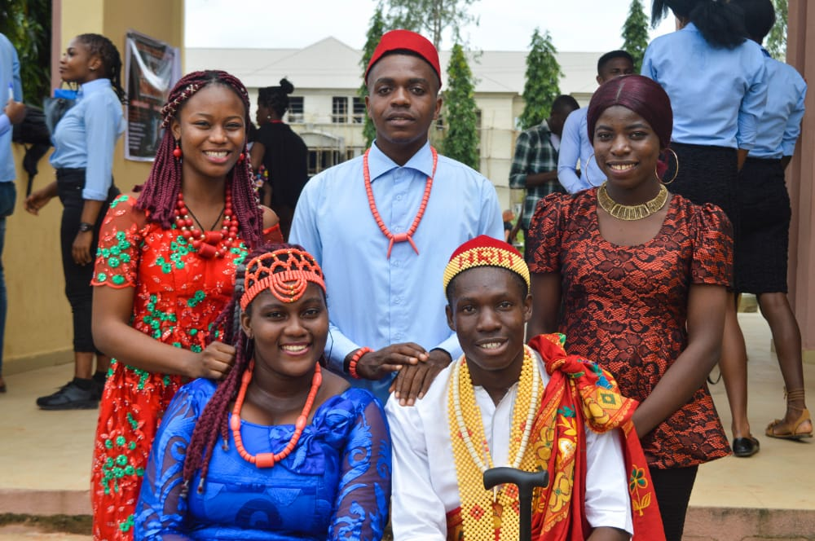

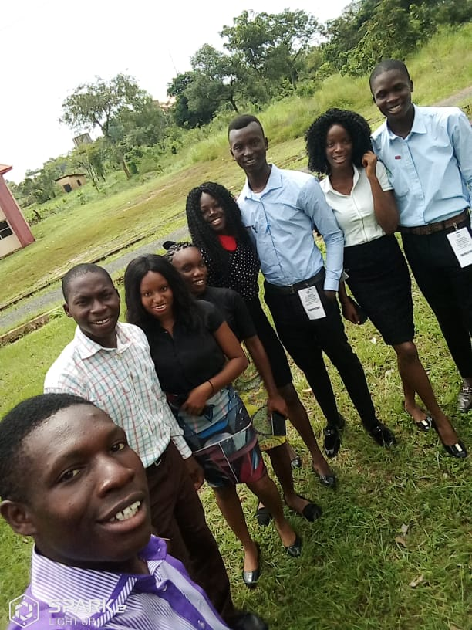Nesanau delegates at southeast zonal conference, Uturu Abia State University

Nesanau delegates with other nesaites in southeast zone, Nigeria

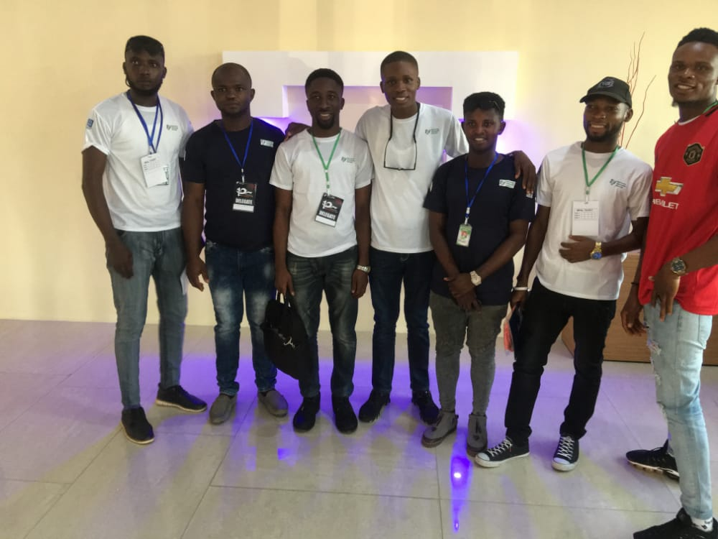

Nesanau delegates award giving as overall Quiz competition winner for southeast zonal conference

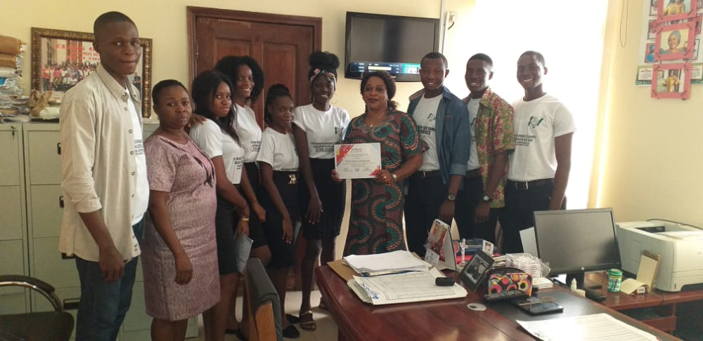

PAREF session

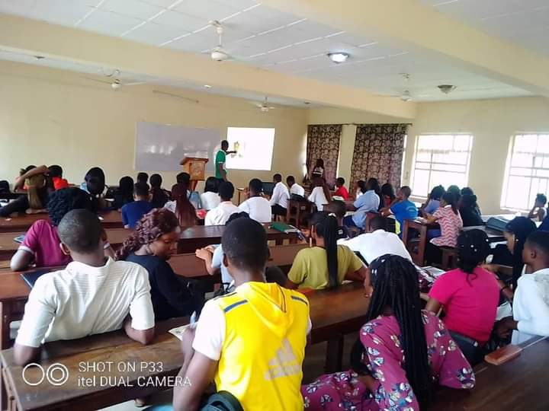

**Our lecturers**

Prof. Uche Collins with Nesanau delegates

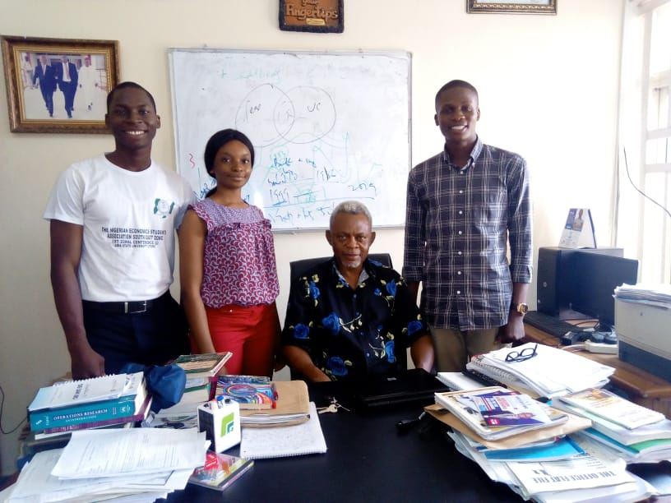

Prof. Ken Oyebuchi Obi with Nesanau delegates 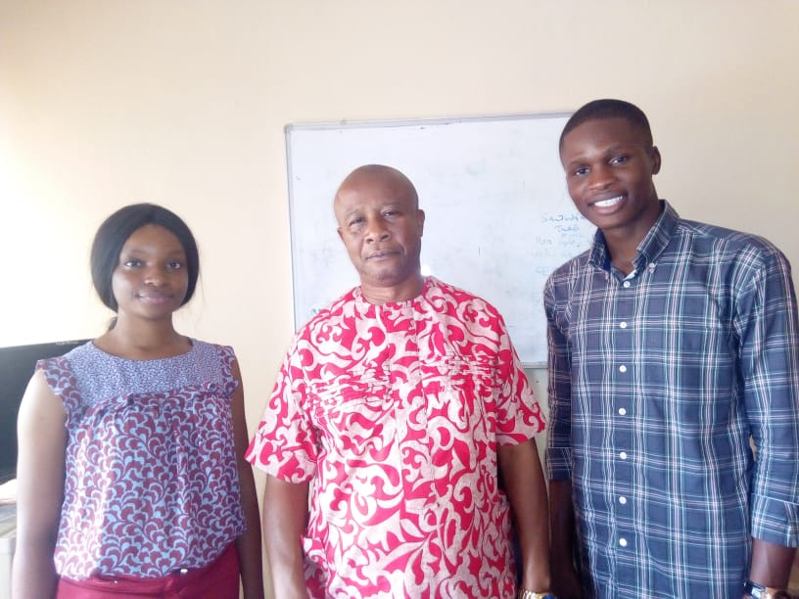

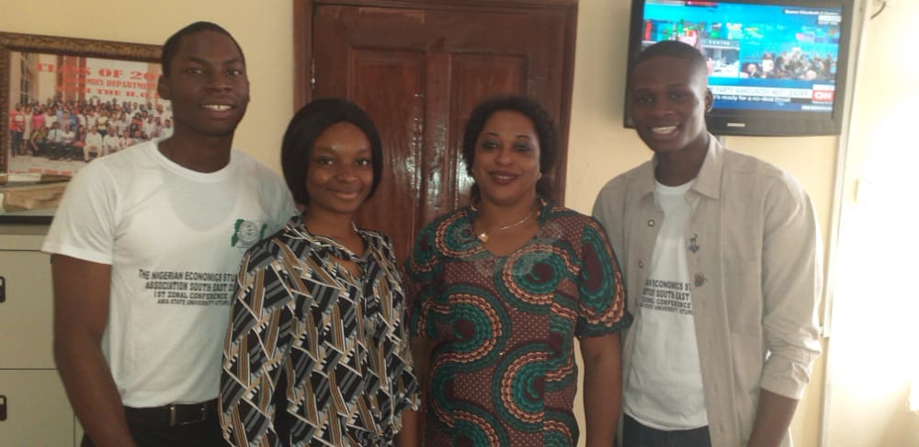

Dr. Uju Ezenekwe (Former HOD) and Nesanau delegates

**Our Institutes**

**Policy analysis and research forum**:

In pursuit of academic excellence and human capital development, the [**Policy Analysis and Research Forum(PAREF)**](https://www.facebook.com/Parefnau/) is equipping young Nigerian economics students with the art of research in related career path by creating a facilitating environment which gives students the platform to make and present their research finding under the auspice of experts in related area of research discipline. PAREF sessions holds once a week every Wednesday by 2pm Nigerian time.

**Nigerian fellowship of economics students:**

Students sometimes faces some mental, psychological and spiritual problems which is deterrent to the healthy academic and social lifestyle. As a means of consolidating the mind of our students, the National Fellowship of Economics Student(NAFECS) will provide spiritual, mental and psychological aid to students with related concerns.

**Our events**

Induction Ceremony

Career Fair

Paref Day

Nafecs Day

Cultural Day

Nesa Competition WeeK

* Essay competition
* Music Competition
* Sports competition
* Comedy Competition
* Virtual debate competition

**Our partners**: coming soon

**Our blog**: proposed blog contents

* NESA students resumes school fully
* How Covid19 has reshaped the academic sector
* NESA student speaks of the Covid19 experience
* How a became a millionaire in 6months; a student story
* 10 Things I wished I knew before becoming an Undergraduate
* Certificate or Sabificate; finding the locus
* The facts and myth of wealth creation in the 21st century
* How to be an effective public speaker
* When the demand curve becomes dysfunctional
* Money and Credit
* LinkedIn the new resume

Our career support

* Scholarships

Receive information here on regular scholarship opportunity

* Resume review
  + Does your resume pass the 10 seconds test? See how to best write your resume to land you your dream job. Here are some free resume review platform.
* Internships
  + Interested in gain work exposure to enrich your CV and become more in demand? Here are a list of companies you can apply to based on your availability. Internship opportunities are both Virtual and Traditional depending on your availability.
    - Virtual Internship programmes
    - Traditional internship programmes
* Mentorships: coming soon
  + Do you need a coach to guide you through your career path? Checkout Nesanau mentorship programmes with partners. Choose your mentorship path:
    - Leadership
    - Public Speaking
    - Finance
    - Business
    - Project Management

**Other requirements requestor by contractor Zaniosoft**

* (1)We need a new logo can you help? Coming ASAP
* (2&3)**Our Contacts**
  + Phone: 08151550083
  + Email: nesaunizikchapter@gmail.com
  + Twitter: https://twitter.com/nau_nesa?s=09
  + LinkedIn: https://www.linkedin.com/in/nesa-nau-19ab031bb
  + Instagram: <https://www.instagram.com/nesa_nau?r=nametag>
* (4.1) The culture of Nigeria is shaped by Nigeria's multiple ethnic groups. The country has over 521 languages and over 1150 dialects and ethnic groups. The four largest ethnic groups are the Hausa and Fulani who are predominant in the north, the Igbo who are predominant in the southeast, and the Yoruba who are predominant in the southwest. Here, members of the Nigerian Economics Students Association at Nnamdi Azikiwe(Nesanau) University demonstrates cultural characteristics of the Igbo couture. It also reflects the Igbo monarchy with the king(Igwe) and Queen(Lolo) as is shown by those fitted in front. Nesa cultural display is an annual event that happens every second semester of the academic session.
* (4.2)Leadership convention is a seasonal convergence that began with the former president of NESA, Comrade Arinze Echezona Nwachukwu in 2019 and was a great opportunity for students in matters of leadership. Young people need the inspiration to be great in life and make better leaders of tomorrow. It was an honor to have great minds men like Hon. Nonso Smart Okafor of Nnewi North Constituency to address the student and inspire them towards their aspirations. We hope for more leadership conference convergence.
* (4.3)The southeast Nesa zonal conference held in 2019 is a conglomeration of Nesa in every university within the southeast region in Nigeria. It was the first of its kind pioneered by the elected then Southeast Zonal Coordinator Comrade Onwubiko Chijioke from Nnamdi Azikiwe University and was held in Abia state university, Uturu. The conference hosted about about 5 universities in the southeast (Unizik, Unn, Absu, Esut, Paul University). The theme of the convention was The Youth and Indecision problem. The experience of the conference being the first of is kind was an unforgettable one which representative from Nesanau who attended it lives to remember having returned with an award as overall best in the interschool quiz competition.
* (5,6,7) **See document head**
* (8) **Statistics Info Requirements**
  + Students: 600+
  + Lecturer: 55+
  + Courses: 40+
* (9) coming ASAP(some info already available at the top of the document)
* (10) coming ASAP
* (11) coming ASAP

Top of Form

Bottom of Form